The Economic Effects of Community Wealth Building in Preston

# Introduction

Prior to the implementation of Community Wealth Building, Preston suffered from a variety of detrimental health and economic problems.

In 2010, 2-3 years prior to the implementation of CWB, the median Lower layer Super Output Area (LSOA) (an LSOA is a collection of typically four or five Output Areas (OAs) which are the lowest level of geographical area for census statistics; an LSOA will typically contain 1,000-1,300 residents (Office for National Statistics, 2023)) in Preston ranked in the bottom 40% on the Index of Multiple Deprivation (IMD), as seen in Table I and Table II.

Table – UK IMD in deciles

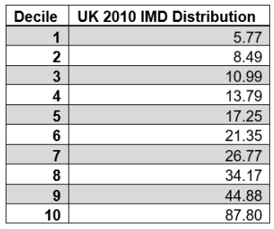

Table – Preston IMD in quartiles

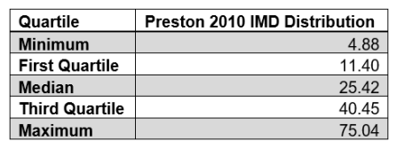

Preston also had an unusually high rate of male suicidality, self-harm-related hospital admissions, eating disorders, etc., for its local area in 2012 (Lancashire JSNA, 2012, pp. 13, 24, 39). Its most deprived districts also featured in the bottom quintile nationally for child wellbeing (ibid, p. 58). Economic problems were further exacerbated when the £700mn Tithebarn regeneration project, proposed in 2005 and meant to bring investment and new jobs to the area, was scrapped in 2011 (Preston City Council, 2019). The local government decided to look towards Community Wealth Building (CWB) to provide employment to ease poverty and other health issues.

CWB aims to keep local wealth from leaving the city and maximise the social value of what that wealth can produce. The city council forms an “anchor network” with “anchor institutions” where all parties agree to uphold certain key values (Preston City Council, 2019, p. 8):

1. Paying a living wage,
2. Progressive procurement,
   1. Contracts awarded to firms should ideally be split up to be available to SMEs.
   2. Procurement should begin locally.
3. Considering not just the economic but also social value of employment, investments, and land use.

The term “anchor institution” refers to large-scale, local employers who are “often tied to a place by their mission, physical assets and local relationships.” (Preston City Council, 2019, p. 10) Examples can include local authorities, NHS trusts, or large local businesses (ibid, p.10).

After an initial investigation in 2012, it was discovered that, of the £750mn spent by anchor institutions in Preston, only “5% of it was spent with organisations based in the Preston boundary, with 39% spent with organisations based in wider Lancashire.” (ibid, p.11) In total, over $458mn was leaving the Lancashire economy. By 2016/17, after the implementation of CWB by the Preston City Council and Lancashire City Council, locally retained spending in Preston increased to 18.2% and in Lancashire increased to 79.2% (ibid, p.11).

New anchor networks have been established by multiple other city councils, including Birmingham, Oldham, Salford, Kirklees, Islington, Enfield, Southampton, Wakefield, Bristol (Preston City Council, 2019) and Leeds (Leeds City Council, n.d.).

# Literature Review

Rose et al. (2023) has examined the Preston Model using a difference-indifferences analysis coupled with a synthetic control methodology. It found that Preston’s CWB has had statistically significant, positive effects on antidepressant prescriptions, depression diagnoses, life satisfaction scores, and median wages when compared to control cities. However, most of these parameters did not display statistically significant difference from the control pool in the final year of analysis, 2019, seen in Figure I.

Figure I

|  |  |
| --- | --- |
|  |  |

Loader (2012) investigated barriers to SMEs participating in the tendering process for public contracts. She found that, while SMEs are underrepresented nationally in the tendering process compared to their constituency of GDP, local authorities have a much better success rate (*ibid*, p. 52). Further, she supports the idea that involving SMEs in the tendering process is an important policy objective, as they can provide better:

1. Responsiveness,
2. Flexibility,
3. Specialist knowledge,
4. Innovativeness,
5. Quality of service,
6. Lowers costs,

and consequently, better value for money. These advantages are supported by Glover (2008). Loader (2012, p. 47), though, suggests that positive discrimination or adopting a SME target is likely inadvisable, due to the variance inherit in a diverse market. Instead, one of the main barriers identified is duration and size of contracts, and the solution is to encourage subcontracting or splitting tendering to be available to SMEs.